CHAPTER – 1

INTODUCTION

#### Project Goal and Objectives

#### Overview of proposed system

#### Scope

**INTRODUCTION**

* “Smart City” is an IOT based project. The internet of things can be used to build a smart city in which all the places/modules in smart city are interconnected with each other with IOT components for efficient usage of resources.
* Smart city can have smart parking system, smart waste management, smart water supply for home or public water tanks, automatic street light, etc.
* Our project is about managing different modules that are used in daily routine like different corporate department of city automatically by using Information Technology, Digital Electronics and some help of Electronic Engineering.
* There is no limit of the things we can include in a smart city.
* In this project, we implement this all modules using Microcontroller, Some IDEs to program the microcontroller, some electronic sensors and sending the data to database and receiving the data from database.

#### 1.1 Project Goal and Objectives

* The objective of “Smart City” Project is about automation of some places that are in the city like Smart parking system, Automatic street light, Smart waste management, smart water supply for home or public tanks to promote cities that provide core infrastructure and give a decent quality of life to its citizens, a clean and sustainable environment.
* Primary Modules of Project:
  + Smart Parking System
  + Smart Waste Management
  + Automatic Street Light
  + Smart Water System

#### 1.2 Overview of proposed system

* In “Smart City” project our team is just trying to manage different places of city with the help of some electronic devices, Information technology and IOT technology.
* Here we are going to discuss the overview of different primary modules of project.

1. **Smart Parking System**

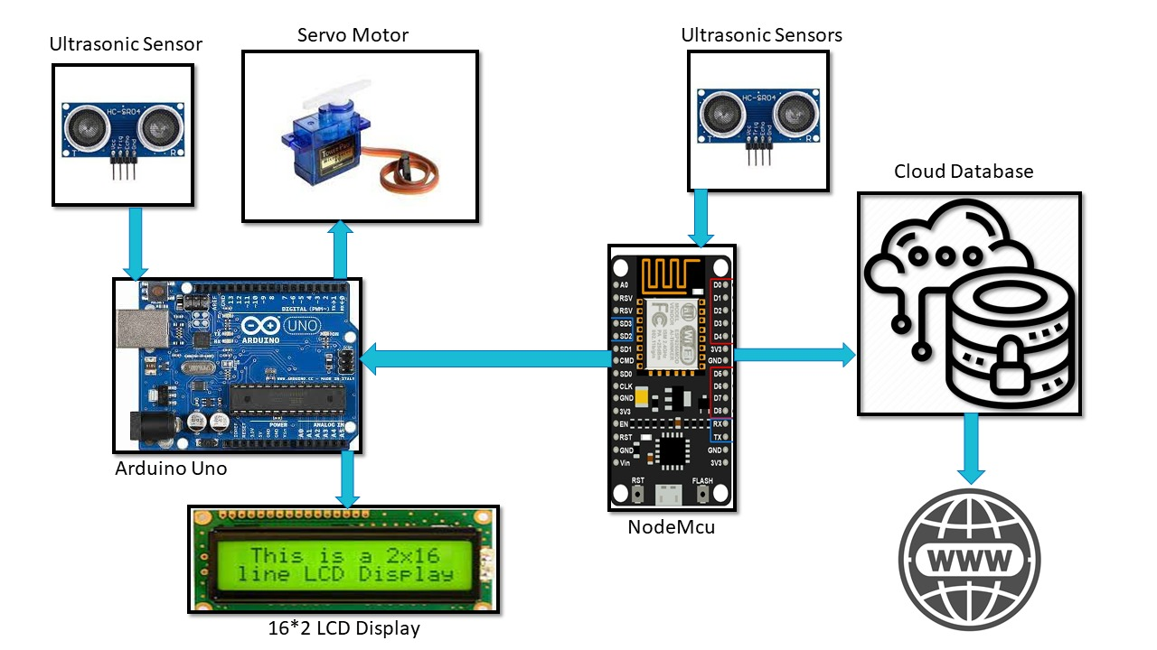

* In smart parking system the status of all parking areas of city is maintained online on database and displaying the status of all parking area on websites and LCD display which is installed outside the parking.
* In parking area, we use different types of sensors to calculate the numbers of vehicle available in parking and free space in parking.
* If there is no free space in parking area, the car will not be allowed to be entered.

1. **Smart Waste System**

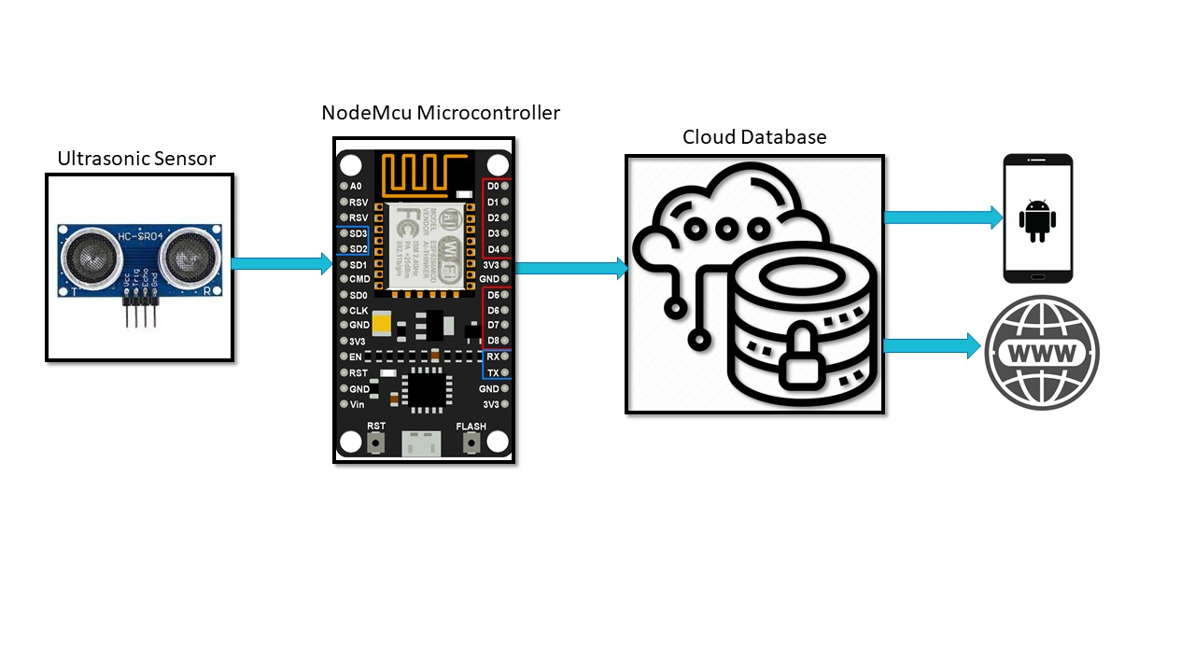

* One of the modules of Smart city is Smart Garbage, as we know there is no automation at all in our current waste system, so there are many problems in present days with workers of waste system like somewhere a dustbin is full but they have no idea about it.
* Our system will cover this problem with the facilities like providing notification service to dumping station so that worker can know about the status of dustbin like if the dustbin is full or not.
* The notification will be sent to dumping station using Arduino microcontroller, ESP8266 Module, Ultrasonic sensor and database and dumping station worker can also observe the status of dustbin.

1. **Smart Water System**

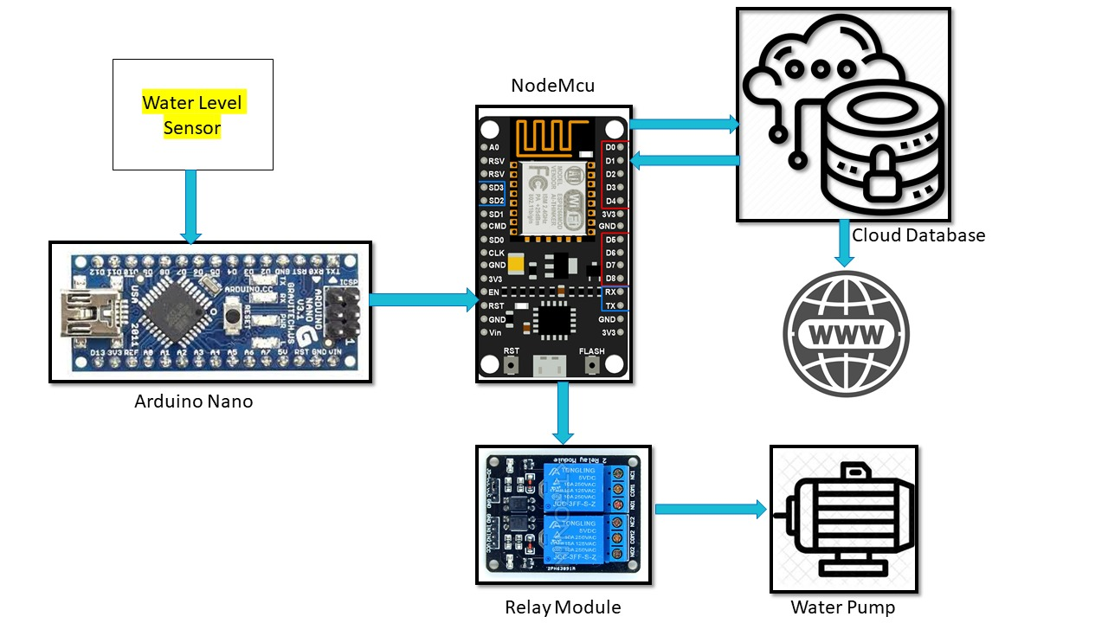

* in smart water distribution system, we will manage the level of water tank of the area automatically using water sensors and microcontroller.
* If the level of water tank goes above 90% the motor will automatically turn off, the supplement of water will be stopped.
* And the water level of tank goes down below 10% the motor will turn on automatically the supplement of water will be resumed.

1. **Street Light System**

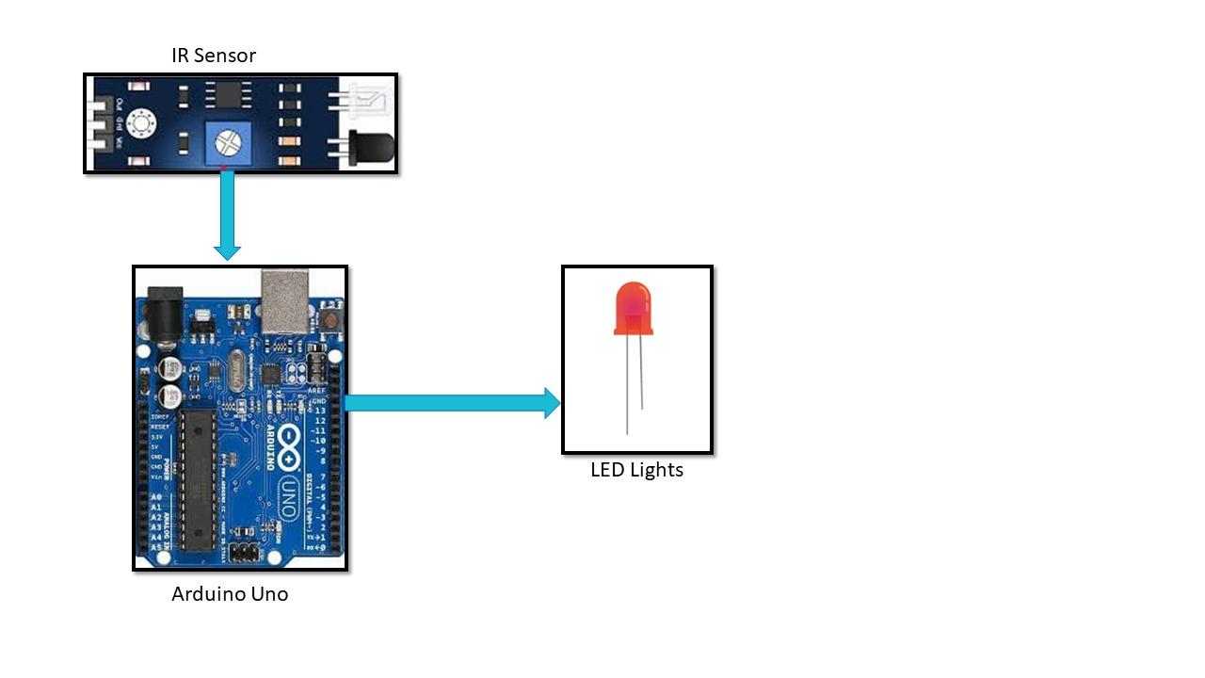

* Presently Street Lights remains on even though no necessary.
* We will cover this problem by providing Each Light the dedicated sensors so if there is no object detect then the lights remain off and if the object is detected then the lights are automatically on using the Arduino microcontroller, LDR sensor, Motion sensor and Database for observing the status of street lights.
* So, using this we can save the electricity.

#### 1.3 Scope

* The user needs an internet connection, with help of internet connection user or vehicle driver can see the status of parking area and if the parking slots is full then it will not allow to park their vehicle and if parking slot is not full then it allows to enter and park their vehicle in particular parking slot. And also, in the smart waste the notification will sent to dumping station from dustbin using an internet connection, database and microcontroller.
* In water supply system also, we need an internet for observing the water level of water tanks. If user don’t have internet then it cannot see the current status of any area in smart city.
* In street light system there is a motion sensor which detects the movement in its surrounding and if any movement is detected then motion sensor sends the signal to microprocessor which controls the light according to the signal.
* No internet service is required for this purpose but if admin wants to observe the status of different street light online, then internet connection is required.